ASCII code assignemnt.

- Print ASCII table from 1 to 100.
You output should look similar to:
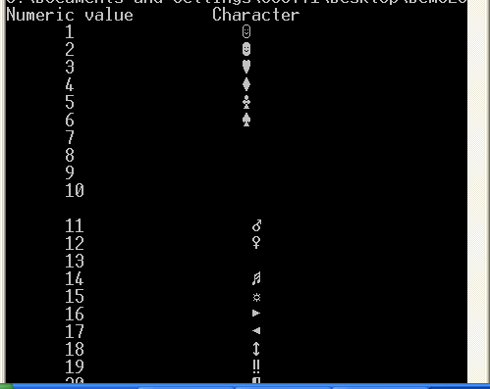

2. Print ASCII values for lowercase characters.

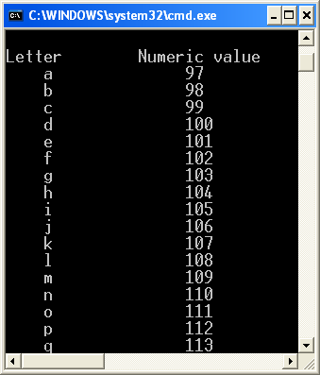

- Ask the user for the input and erase all the non-letter characters – spaces, commas, explanation marks and so on.
For example, if the user enters:
I don’t like this assignment!!#*($&#(*&
You should print
Idontlikethisassignment

- Ask the user for the number and print an error message if a nonnumeric characters has been entered.

Example 1
Enter a number: 20
Thanks

Example 2
Enter a number: 20abc
Error, please enter a number: 30-90
Error, please enter a number: 7.456
Thanks

